**DAILY ONLINE ACTIVITIES SUMMARY**

|  |  |  |  |  |  |  |  |  |
| --- | --- | --- | --- | --- | --- | --- | --- | --- |
| **Date:** | **25/06/2020** | | | | | **Name:** | **ASHISH GRACION MENEZES** | |
| **Sem & Sec** | **4&A** | | | | | **USN:** | **4AL18CS012** | |
| **Online Test Summary** | | | | | | | | |
| **Subject** | | **N/A** | | | | | | |
| **Max. Marks** | | **N/A** | | **Score** | | | **N/A** | |
| **Certification Course Summary** | | | | | | | | |
| **Course** | **STATISTICAL METHODS FOR DECISION MAKING** | | | | | | | |
| **Certificate Provider** | | | **Great Learning** | | **Duration** | | | **7.5 hours** |
| **Coding Challenges** | | | | | | | | |
| **Problem Statement1:Write a C program to reverse the rows in a 2d array** | | | | | | | | |
| **Status:Executed** | | | | | | | | |
| **Uploaded the report in Github** | | | | | **YES** | | | |
| **If yes Repository name** | | | | | **https://github.com/ash7745/lockdown-coding** | | | |
| **Uploaded the report in slack** | | | | | **YES** | | | |

Online Test Details1: N/A

Certification Course Details: STASTICAL METHODS FOR DECISION MAKING

I have started a new course

Today I have completed 4 modules

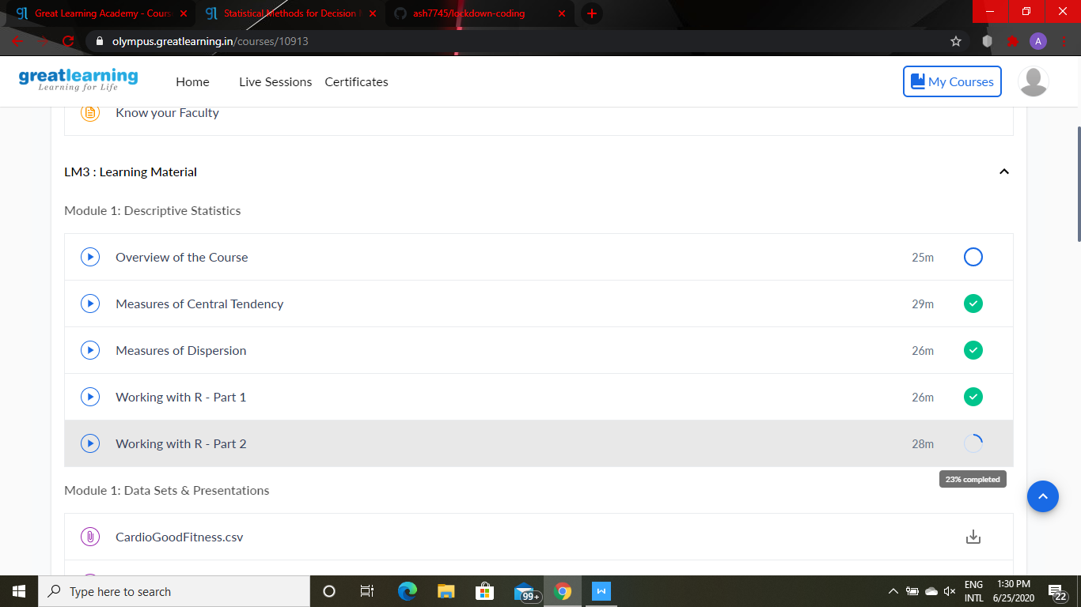

Webinar details: Webinar on C++

Attended a session on C++ program(9:00am to 10:30am) which was organized by AIET Placement Department in Google meet and the session was conducted by Prof.Shruthi Shetty .The duration of the session was 1.5 hours. A quiz was conducted on the particular topic at the end of the session

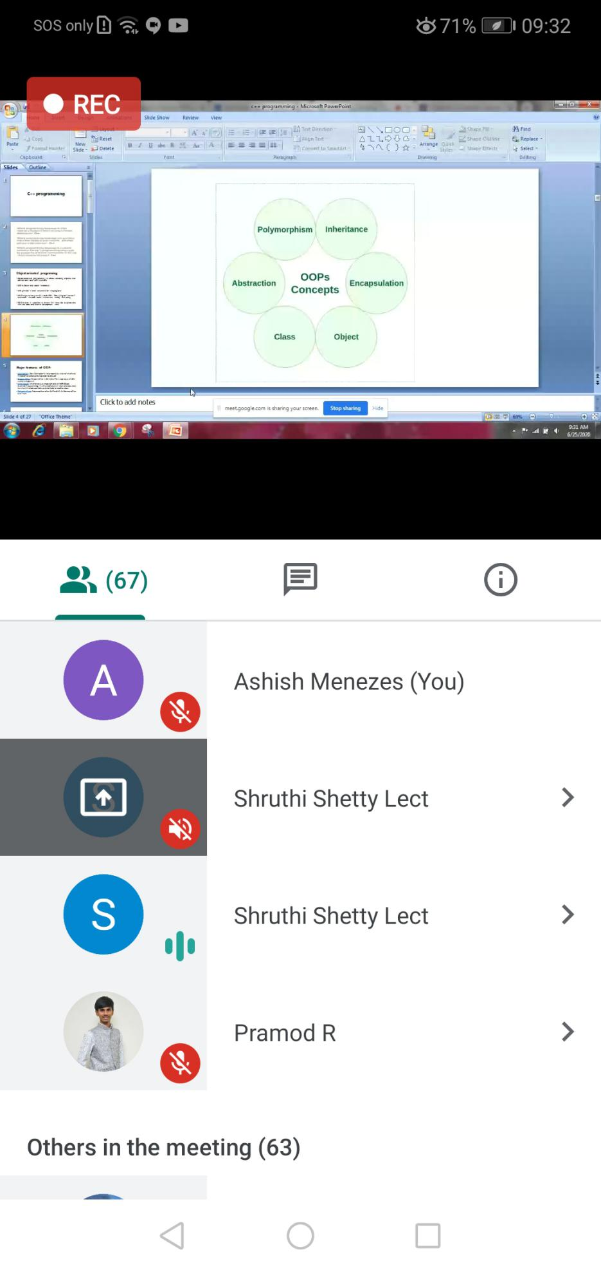

CODING DETAILS: Write a C program to reverse the rows in a 2d array

